MySQL DROP VIEW

Introduction to the MySQL DROP VIEW statement

The DROP VIEW statement deletes a [view](https://www.mysqltutorial.org/mysql-views-tutorial.aspx) from the database. Here is the basic syntax of the DROP VIEW statement:

**DROP** **VIEW** [**IF** **EXISTS**] view_name;

Code language: SQL (Structured Query Language) (sql)

In this syntax, you specify the name of the view that you want to drop after the DROP VIEW keywords.

The IF EXISTS option conditionally removes a view only if the view exists.

To remove multiple views at once, you can use the following syntax:

**DROP** **VIEW** [**IF** **EXISTS**] view_name1 [,view_name2]...;

Code language: SQL (Structured Query Language) (sql)

In this syntax, if any view specified after the DROP VIEW clause does not exist, the DROP VIEW statement fails and does not delete any view.

If you use the IF EXISTS option and there are some views that do not exist, the DROP VIEW statement generates a NOTE for each non-existing view.

Note that in MySQL 5.7 or earlier, the DROP VIEW returns an error if there is any non-existing view. However, it drops the views that exist.

MySQL DROP VIEW statement examples

Let’s take some examples of using the DROP VIEW statement.

1) MySQL DROP VIEW – drop a view example

This statement [creates a view](https://www.mysqltutorial.org/create-sql-views-mysql.aspx) named customerPayments based on the customers and payments tables:

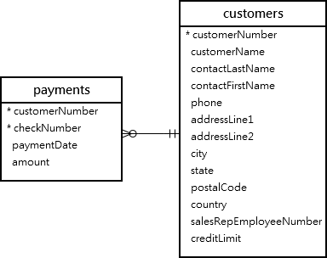

**CREATE** **VIEW** customerPayments

**AS**

**SELECT**

customerName,

**SUM**(amount) payment

**FROM**

customers

**INNER** **JOIN** payments

**USING** (customerNumber)

**GROUP** **BY**

customerName;

Code language: SQL (Structured Query Language) (sql)

This example uses the DROP VIEW statement to drop the customerPayments view:

**DROP** **VIEW** **IF** **EXISTS** customerPayments;

Code language: SQL (Structured Query Language) (sql)

2) MySQL DROP VIEW – drop multiple views example

This statement [creates a view](https://www.mysqltutorial.org/create-sql-views-mysql.aspx) named employeeOffices based on the employees and offices tables:

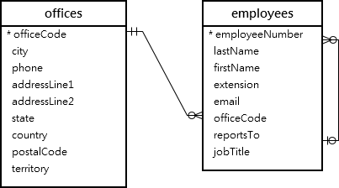

**CREATE** **VIEW** employeeOffices **AS**

**SELECT**

firstName, lastName, addressLine1, city

**FROM**

employees

**INNER** **JOIN**

offices **USING** (officeCode);

Code language: SQL (Structured Query Language) (sql)

The following statement uses the DROP VIEW statement to delete two views employeeOffices and eOffices:

**DROP** **VIEW** employeeOffices, eOffices;

Code language: SQL (Structured Query Language) (sql)

MySQL issued the following error:

Error Code: 1051. Unknown table 'classicmodels.eoffices'

Code language: SQL (Structured Query Language) (sql)

Let’s add the IF EXISTS option:

**DROP** **VIEW** **IF** **EXISTS** employeeOffices, eOffices;

Code language: SQL (Structured Query Language) (sql)

MySQL issued a warning instead:

1 warning(s): 1051 Unknown table 'classicmodels.eoffices'

Code language: SQL (Structured Query Language) (sql)

The employeeOffices view remains intact.

This statement [creates a new view](https://www.mysqltutorial.org/create-sql-views-mysql.aspx) named productCatalogs based on the products and productLines tables:

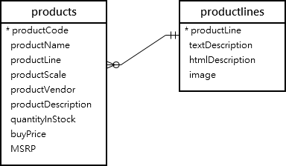

**CREATE** **VIEW** productCatalogs **AS**

**SELECT**

productLine, productName, msrp

**FROM**

products

**INNER** **JOIN**

productLines **USING** (productLine);

Code language: SQL (Structured Query Language) (sql)

The following example uses the DROP VIEW statement to delete the employeeOffices and productCatalogs views:

**DROP** **VIEW** employeeOffices, productCatalogs;

Code language: SQL (Structured Query Language) (sql)

Both views are now deleted successfully.